
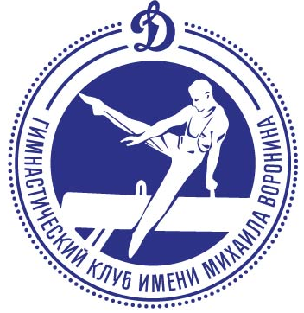 XXVI VORONIN CUP 2019

Penza, Russia 27.11-01.12.2019 DS «Burtasy»

The schedule of competitions

 | 27.11.2019
All day | Arrival delegations.  Accommodation in hotels.
All day | Registration of participants and judges.  Trainings under the free schedule (warm-up hall).
18.00 | Meeting of heads delegations, judges and coaches. Conference room.
 | 28.11.2019
10.00 – 12.00 | Women (juniors, seniors). Testing training
12.00 | Judge meeting – Men, Women.
14.00 – 16.00 | Men (juniors). Testing training.
16.00 – 18.00 | Men (seniors). Testing training.
 | 29.11.2019
09.00 | Judge meeting – Women.
09.10 – 10.00 | Podium warm-up. Women (juniors, seniors) / apparatus - 10 minutes
10.00 – 12.00 | Competition I, II, IV. Women (juniors, seniors).
12.00 | Judge meeting – Men.
12.00 – 12.42 | Podium warm-up. Men (juniors) / apparatus - 7 minutes
12.45 – 14.45 | Competition I, II, IV. Men (juniors).
15.00 – 15.45 | Opening Ceremony.  Rewarding of conquerors and prize-winners of competitions.  Women (juniors, seniors).
16.00 – 16.48 | Podium warm-up. Men (seniors) / apparatus - 8 minutes
16.50 – 18.50 | Competition I, II, IV. Men (seniors).
19.00 | Rewarding of conquerors and prize-winners of competitions.  Men (juniors, seniors).
 | 30.11.2019
10.00 – 10.50 | Training participants in the finale.
10.30 | Judge meeting – Men, Women.
11.00 – 16.00 | Competition III. Men (juniors), Men.  Individual apparatus finals. Rewarding during competition.
11.40 – 16.00 | Competition III. Women (juniors), Women.  Individual apparatus finals. Rewarding during competition.
 | 01.12.2019
All day | Depart delegations.

